

Embedded Systems Design

**Lab1**

Reporters:Zheng Dong 董政

Date:2020-6-11

1. **description of project creation and programming the board**

First，I create a new stm32 project.

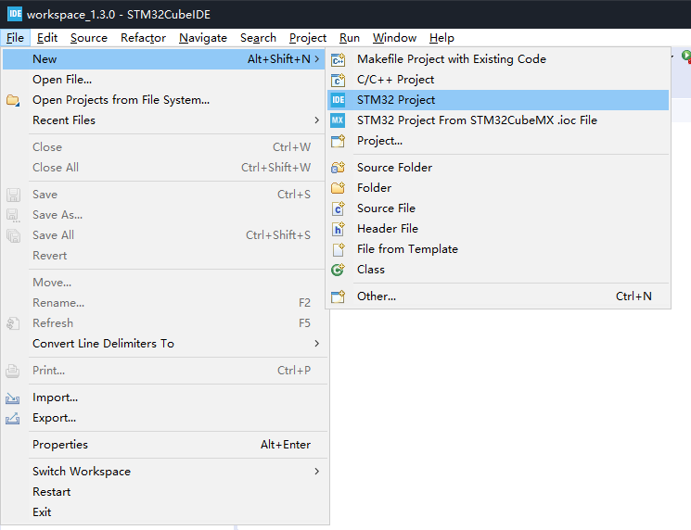

After that,Select MCU,my MCU is STM32F429ZI.

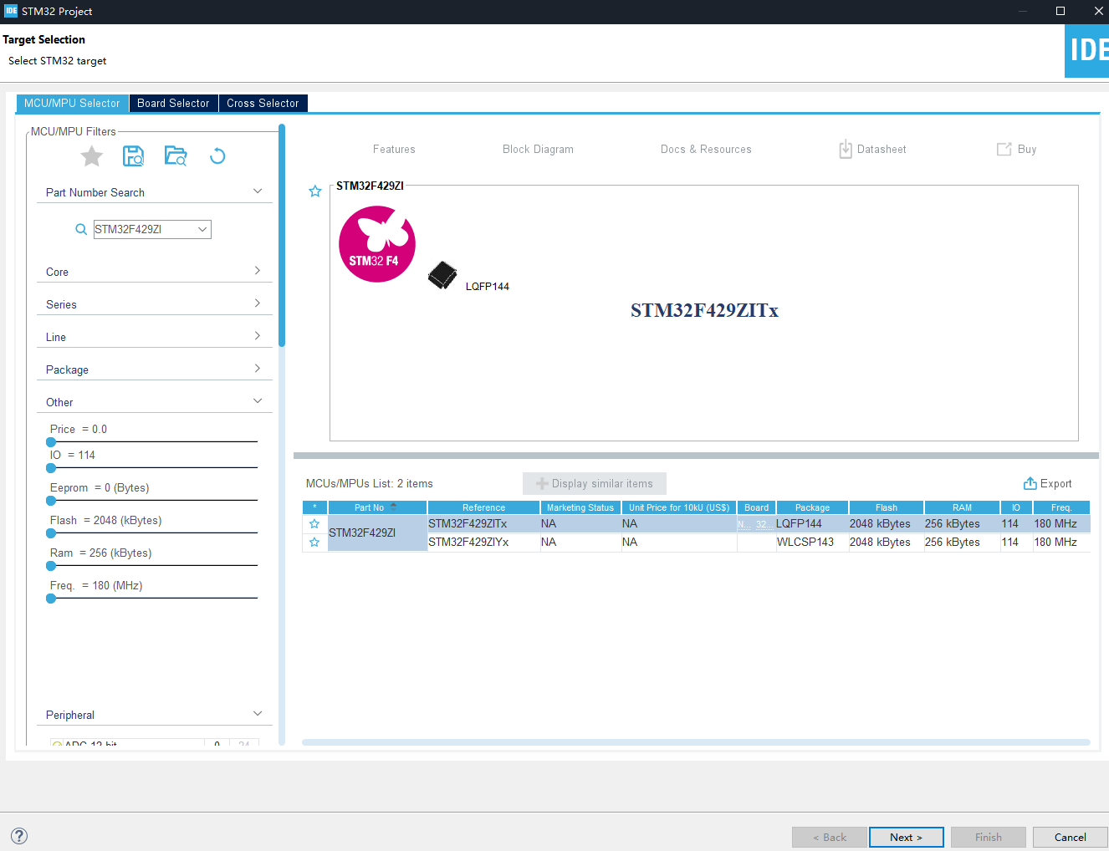

Then,Select the name of my project.

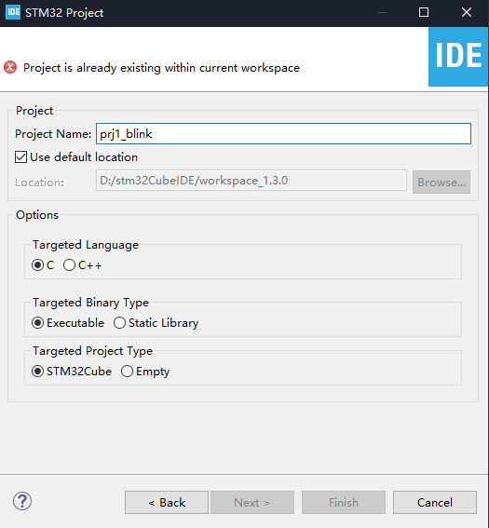

A blue user LED is connected to PB7,a red user LED is connected to PB14.So,I switch it to the GPIO_output.

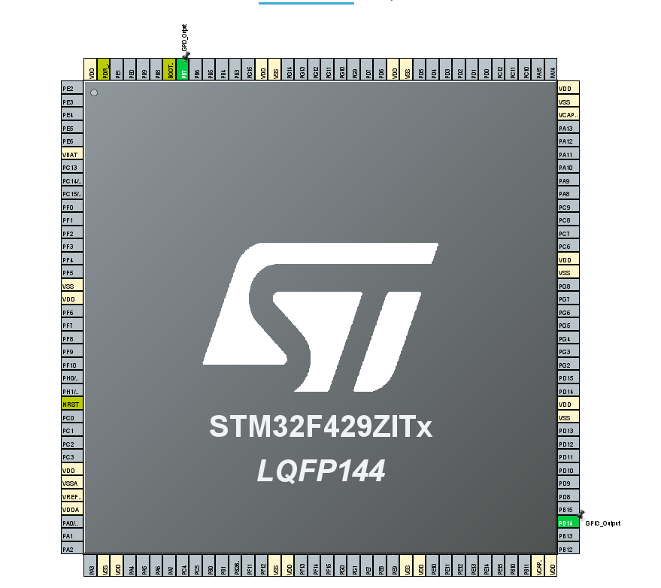

Finally,I Insert the code for flashing the led like this.

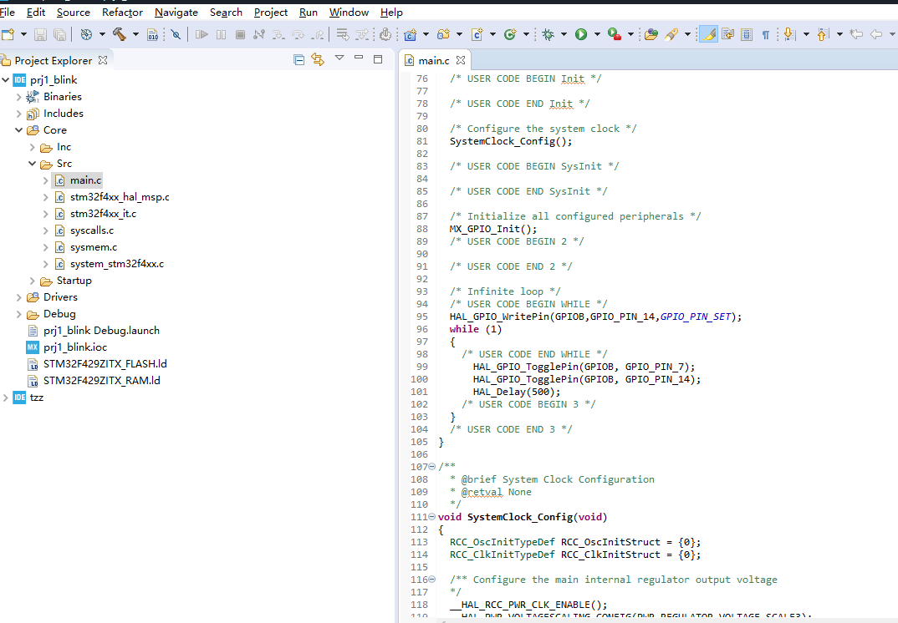

1. **The result**

We can see blue and red LED lights flashing.

The short video link:https://github.com/dzz5201314/esd_lab